**Assignment No- 2**

1)Write a program that checks if a given year is a leap year or not using both if-else and switch-case.

import java.util.Scanner;

public class leap {

    public static void main(String []args){

        System.out.println("enter a number");

        Scanner sc = new Scanner(System.in);

        int year = sc.nextInt();

        if((year % 4 ==0 && year % 100 !=0 ) ||(year % 400 == 0)){

            System.out.println(year + "is a leap year");

        }

        else{

            System.out.println(year + "is not a leap year");

        }

        sc.close();

    }

}

Output: 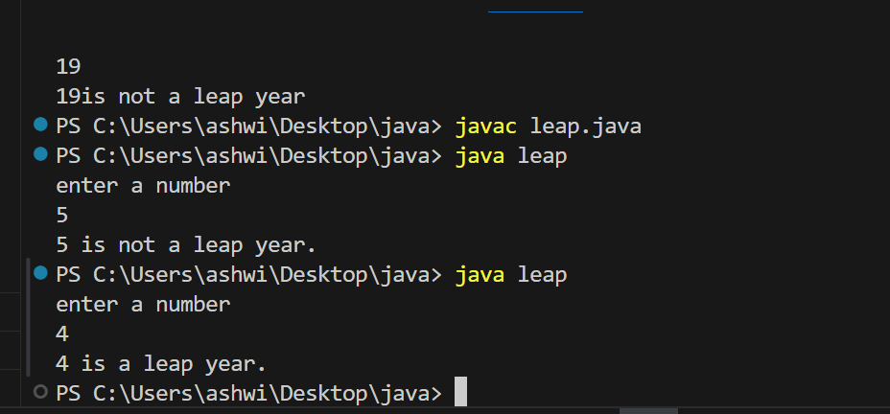

import java.util.Scanner;

public class leap{

    public static void main(String[]args){

        System.out.println("enter a number");

        Scanner sc = new Scanner(System.in);

        int year = sc.nextInt();

        sc.close();

        int leapcheck = ((year % 4 ==0 && year % 100 !=0 ) ||(year % 400 == 0)) ? 1 : 0;

        switch (leapcheck) {

            case 1:

                System.out.println(year + " is a leap year.");

                break;

            case 0:

                System.out.println(year + " is not a leap year.");

                Break;

    }

}

}

2)Implement a program that calculates the Body Mass Index (BMI) based on height and weight input using if-else to classify the BMI int categories (underweight, normal weight, overweight,etc).

Program:

import java.util.Scanner;

public class Bmi {

    public static void main(String[]args){

        Scanner sc = new Scanner(System.in);

        System.out.println("enter your weight in kg");

        double weight = sc.nextDouble();

        System.out.println("enter your height in kg");

        double height = sc.nextDouble();

        sc.close();

        double bmi= weight/ (height*height);

        System.out.printf("Your BMI is: %.2f\n", bmi);

       if (bmi < 18.5) {

            System.out.println("You are underweight.");

        } else if (bmi >= 18.5 && bmi < 24.9) {

            System.out.println("You have a normal weight.");

        } else if (bmi >= 25 && bmi < 29.9) {

            System.out.println("You are overweight.");

        } else {

            System.out.println("You are obese.");

        }

    } }

Output:

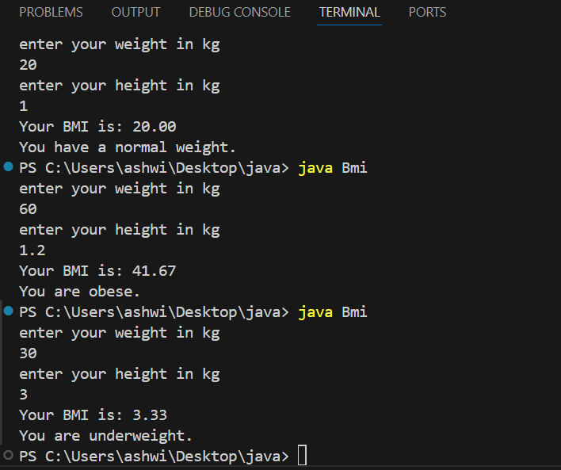

3)Write a program that checks if a person is eligible to vote based on their age.

Program:

import java.util.Scanner;

public class vote {

    public static void main(String[] args) {

        System.out.println("Enter your age");

        Scanner sc = new Scanner(System.in);

        int age = sc.nextInt();

        if(age>= 18){

            System.out.println("eligible for voting");

        }else{

            System.out.println("not eligible for voting");

        }

        sc.close();

    }

}

Output:

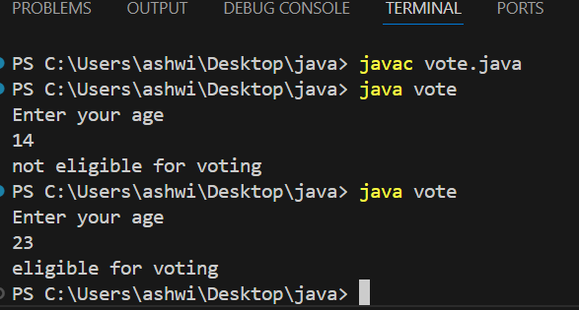

4)Write a program that takes a month (1-12) and prints the corresponding season (Winter, Spring, Summer, Autumn) using a switch case

Program:

import java.util.Scanner;

public class season {

    public static void main(String[] args) {

        Scanner sc = new Scanner(System.in);

        System.out.print("Enter the month number (1-12): ");

        int month = sc.nextInt();

        switch(month){

            case 12:

            case 1:

            case 2:

            System.out.print("winter");

            break;

            case 3:

            case 4:

            case 5:

            System.out.print("spring");

            break;

            case 6:

            case 7:

            case 8:

            System.out.print("summer");

            break;

            case 9:

            case 10:

            case 11:

            System.out.print("autumn");

            break;

            default:

                System.out.println("Invalid month number! Please enter a number between 1 and 12.");

                break;

        }

        sc.close();

        }

Output:

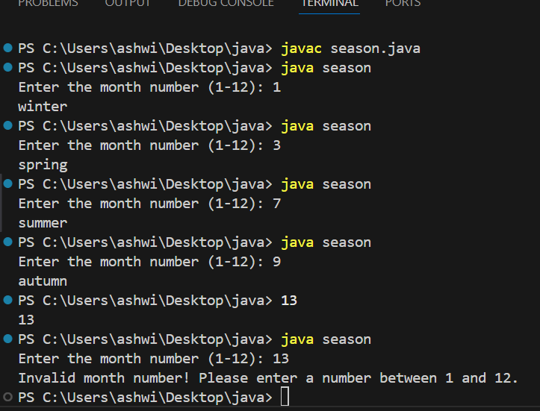

5)Write a program that allows the user to select a shape (Circle, Square, Rectangle, Triangle) and then calculates the area based on user-provided dimensions using a switch case.

program:

import java.util.Scanner;

public class area{

      public static void main(String[] args) {

        Scanner sc = new Scanner(System.in);

        System.out.println("Select a shape to calculate the area:");

        System.out.println("1. Circle");

        System.out.println("2. Square");

        System.out.println("3. Rectangle");

        System.out.println("4. Triangle");

        System.out.print("Enter your choice (1-4): ");

        int choice = sc.nextInt();

        double area = 0;

        switch (choice) {

            case 1: // Circle

                System.out.print("Enter the radius of the circle: ");

                double radius = sc.nextDouble();

                area = Math.PI * radius * radius;

                System.out.println("Area of the Circle: " + area);

                break;

            case 2: // Square

                System.out.print("Enter the side length of the square: ");

                double side = sc.nextDouble();

                area = side * side;

                System.out.println("Area of the Square: " + area);

                break;

            case 3: // Rectangle

                System.out.print("Enter the length of the rectangle: ");

                double length = sc.nextDouble();

                System.out.print("Enter the width of the rectangle: ");

                double width = sc.nextDouble();

                area = length * width;

                System.out.println("Area of the Rectangle: " + area);

                break;

            case 4: // Triangle

                System.out.print("Enter the base of the triangle: ");

                double base = sc.nextDouble();

                System.out.print("Enter the height of the triangle: ");

                double height = sc.nextDouble();

                area = 0.5 * base * height;

                System.out.println("Area of the Triangle: " + area);

                break;

            default:

                System.out.println("Invalid choice! Please select a number between 1 and 4.");

                break;

        }

        sc.close();

    }

}

Output:

